

~~The Interactive Notebook~~

The Virtual Interactive Notebook

* ~~Get a spiral or permanently bound notebook with regularly sized paper in it~~
* Ust the template below to start setting up your Virtual Interactive Notebook. When we go face-to-face, we can convert what we do to a physical notebook.
* S~~tarting with the first page, begin numbering the pages 1,2,3,4,5, etc. Odd # pages should be on the right side, even # pages should be on the left side~~
* ~~Now take the informational handouts and cut/glue them into the appropriate pages:~~

~~**If you do not have a printer, that’s OK (I don’t even have one at home)! I will leave copies for pick up outside of room 317 . Alternatively you can also summarize the pages in your own writing.~~

[VIANB Template](https://docs.google.com/presentation/d/1bpeFZKfsNXvjsA8TF1YNIP4WMIkJOu71Jg3VB6x0Xg0/edit?usp=sharing)  [How to Take a Screenshot](https://www.take-a-screenshot.org/)

**Page(s)**

1 6 word memoir + the backstory

2-3 Table of Contents (TOC)

4 [PhUn Syllabus](https://drive.google.com/file/d/1BcM7Ba2rD5dDwtQWr6Oudcc7X40h36v0/view?usp=sharing)

5 Cornell [Notes](https://docs.google.com/document/d/16NndGUgDr2mWJYdkU1DuwPGQ3HK3Ok0970mIfVhwUhA/view)

6 Marking the [Text](https://docs.google.com/document/d/1XxQgYgy-qYUheec2oIgIxymZNnxgPQhyIRlxToM5r7o/view)

7 GIST [Summary](https://drive.google.com/file/d/0BzAsdpWut9ZeakhJcEowa08zNnM/view)

8 Left [Side](https://drive.google.com/file/d/0BzAsdpWut9ZeTE5BRHJVdDBVMDQ/view)

9 Right [Side](https://drive.google.com/file/d/0BzAsdpWut9ZeTGxhX0VwVGR2dG8/view?usp=sharing)

10 This is where we start filling out the rest of the VIANB

Lastly, go back and skim the informational handouts that you now have in your class notebook. This is *SO* much information, and we will really get to know all of it as we move through the course, so don’t worry about knowing/memorizing everything at this point; just become familiar with it at this point. This will be the notebook that stays with YOU so that you can complete, follow, study, go over what you learned, etc. We will turn in this notebook for credit at the end of each unit.

Example How each page should be done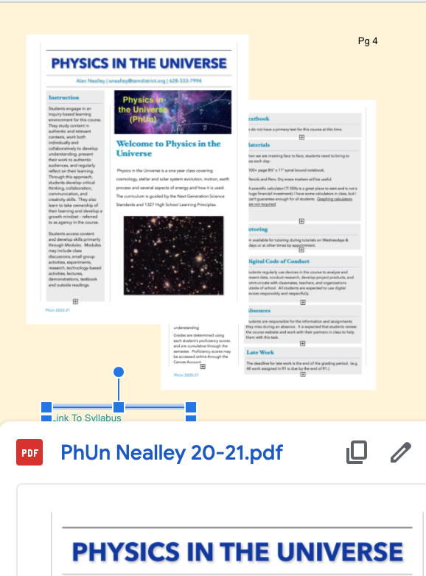

* A separate screenshot for each page of the document
  + 2 pages = 2 screenshots, 4 pages = 4 screenshots
  + We don’t need to be able to read what is on the page
  + We do need to be able to see what the document looks like
* A link to the digital document
  + This gives the viewer the ability to “read” what is on the document and examine it in greater detail